**Suzanne and Joyce Wolfe Families**

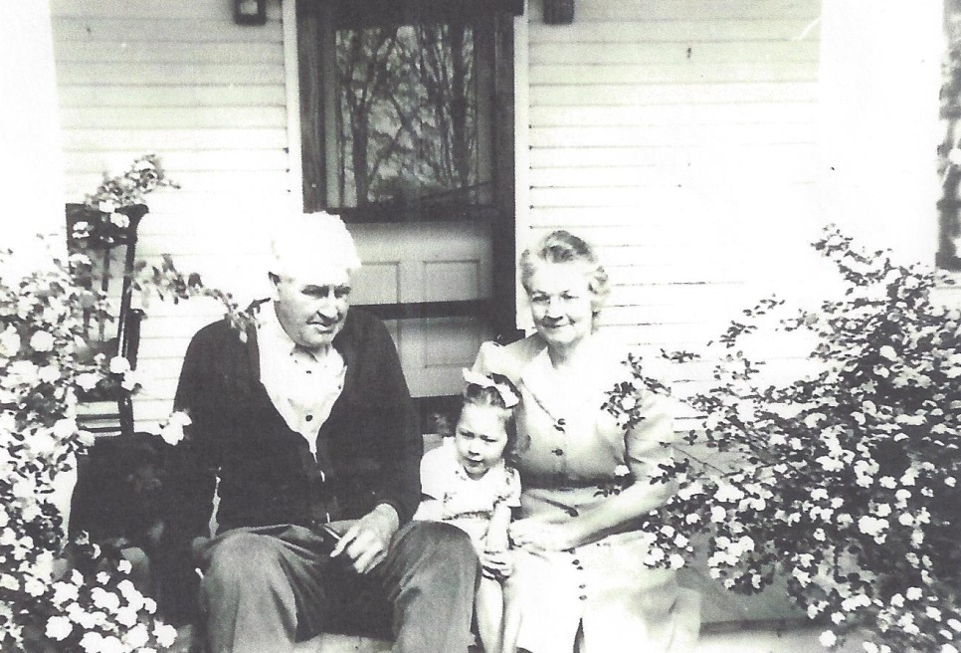

**(l-r) Earl Russell Wolfe, Suzanne Kay Wolfe,**

**Josephine Sybil Worthen Wolfe**

**Walnut Bend, Wolfe Road – 1945 or 1946**

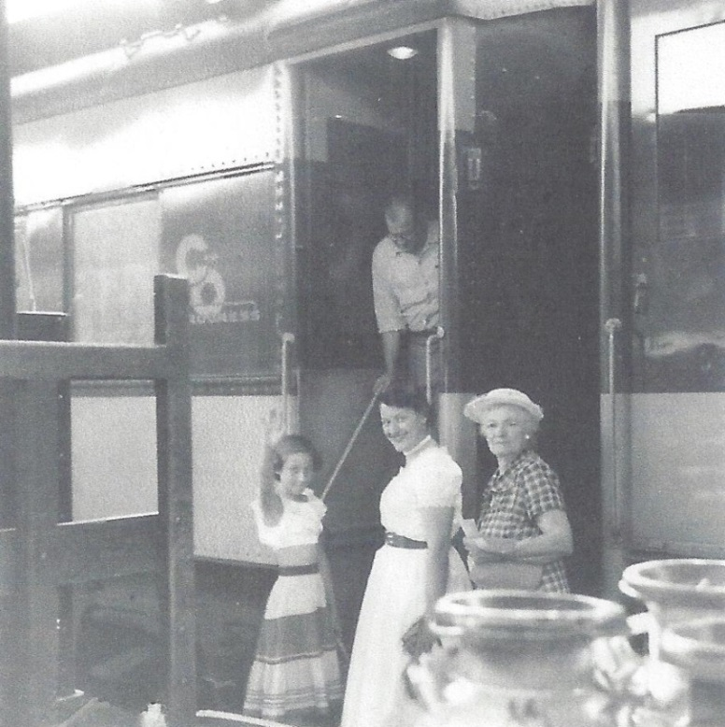

**A Day Trip to Detroit Ford Museum: Suzanne Kay Wolfe,**

**Dottie Joanne List, Josephine S. Wolfe – about 1957 (est)**